UNITED WAY OF GREATER ROCHESTER AND THE FINGER LAKES JOB DESCRIPTION:

TOGETHERNOW ADMINISTRATIVE SPECIALIST

Join the team!
TogetherNow is a dynamic and collaborative work environment comprised of dedicated professionals who are driven to make our community a better place. Join our team and make an impact serving our region with your time and talent.

Mission
Our mission is to unite the goodwill and resources of our community so that everyone can thrive. That means that our team is committed to working with local donors, businesses, not-for-profit program partners, municipalities, and individuals to make this region stronger and more vibrant together.

Values
Our core values define who we are and how we serve our community. United Way and our team members are caring, collaborative, equity-driven, innovative, respectful, results-oriented, and trustworthy. United Way strives to ensure employees and external partners feel valued, connected, and empowered.

What We Offer
• Competitive financial and wellness benefits • Generous paid time off, retirement plan, and other fringe benefits • Hybrid working arrangements • Opportunities to give back to the community in life-changing ways • Paid professional development • Team events and internal committees for connection opportunities and fun!

TogetherNow Administrative Specialist
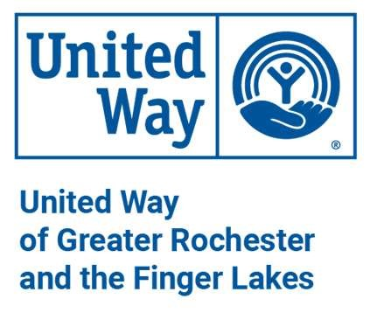
The TogetherNow Administrative Specialist is responsible for the administrative facilitation and support of the TogetherNow Leadership and Team. Working independently and collaboratively in a fast-paced environment with changing priorities, this position performs a broad range of executive administrative, organization, and coordination duties. This position serves as the primary administrative point of contact for the Assistant Director, Senior Project Manager, and the larger team at TogetherNow.

The Administrative Specialist works closely with the TogetherNow Leadership Team, The Business
Operations Administrator, The TogetherNow Team, Project Workgroups, and Community Members. This position also leads and supports special projects, initiatives, meetings, and events.

Position Overview
This role is integral to the operational and administrative support of the TogetherNow Leadership and Team, ensuring smooth and efficient business operations. The candidate will work closely with the Business Operations Administrator and play a pivotal role in managing and executing a variety of administrative tasks, office operations, and special projects.

Key Responsibilities:
- Administrative Excellence: Assist the TogetherNow Leadership and Team with a broad range of administrative tasks, including but not limited to managing correspondence, organizing data for reports, and executing Council meetings from planning through to administrative execution.
Revised: 7/2023

- Operational Coordination: Work in tandem with the Business Operations Administrator to enhance office operations, including implementing processes, scheduling, travel arrangements, and managing supply and space needs.
- Schedule Management: Take proactive charge of the Leadership Team’s schedules, coordinating meetings, conferences, and travel efficiently. Manage multiple email accounts and office calendars to ensure optimal organization.
- Financial Administration: Oversee the submission of expense reports, monitor finance expenses, and maintain financial documents and reports with precision.
- Team and Project Support: Provide comprehensive support for team administrative requests, participate in cross-department collaborations, and lead special project management. Contribute to standardized office operations and manage ad hoc committee involvements.
- Content Creation and Management: Develop content and presentations using a suite of software including Word, PowerPoint, Confluence, Asana, and Adobe, ensuring high-quality materials are produced.
- Professional Development: Maintain up-to-date professional and technical knowledge to stay operationally efficient and contribute effectively to the team.
- Community Engagement: Represent TogetherNow in the United Way Admin Cohort, demonstrating and promoting the organization's values and mission.
- Additional Duties: The role includes other responsibilities as required, embodying flexibility and a willingness to contribute to the team’s success.
Education and Experience
High School Diploma or equivalent with 2 years of administrative assistant experience required; or equivalent combination of education and experience. Associate or Bachelor’s degree preferred. At least 5 years experience in providing support for upper-level management in comparable department or organization preferred. Non-profit experience preferred.

FLSA CLASSIFICATION: Non-exempt

SALARY RANGE: $23.08/hour - $25.64/hour based on a 37.5-hour workweek.

REPORTS TO: Business Operations Administrator

SUPERVISORY RESPONSIBILITY: None

TRAVEL: Local travel may be required occasionally.

HOW TO APPLY :

CLICK HERE TO APPLY https://recruiting.myapps.paychex.com/appone/MainInfoReq.asp?R_ID=6134176

This job description lists only the responsibilities and qualifications deemed essential to the position in support of the ADA. Reasonable accommodations may be provided to enable individuals with disabilities to perform essential functions. United Way of Greater Rochester and the Finger Lakes is an Equal Opportunity Employer. This policy prohibits discrimination based on sex, race, color, religion, creed, national origin, age, marital status, sexual orientation, gender expression, disability, genetic predisposition, veteran status, or status as a member of any protected group or activity.

Revised: 09/2023

